Lab 1 – CSW 430 – Mobile Application Development
Question 1:
Finishing creating a repository.
Link: https://github.com/chaunhattang/CSW430-Mobile-Application-Development.git
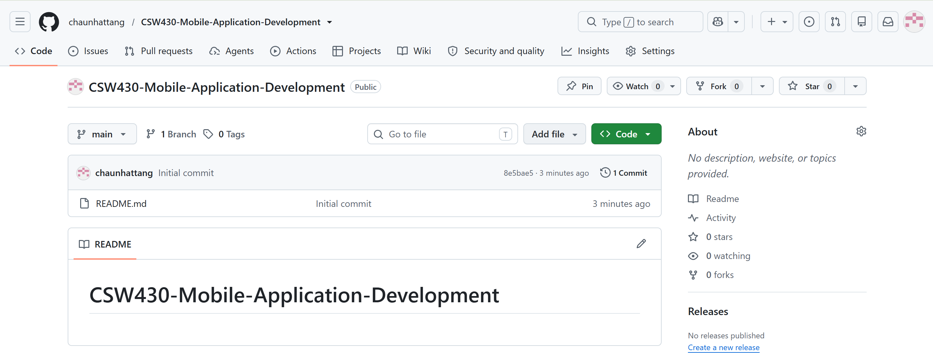
Question 2:
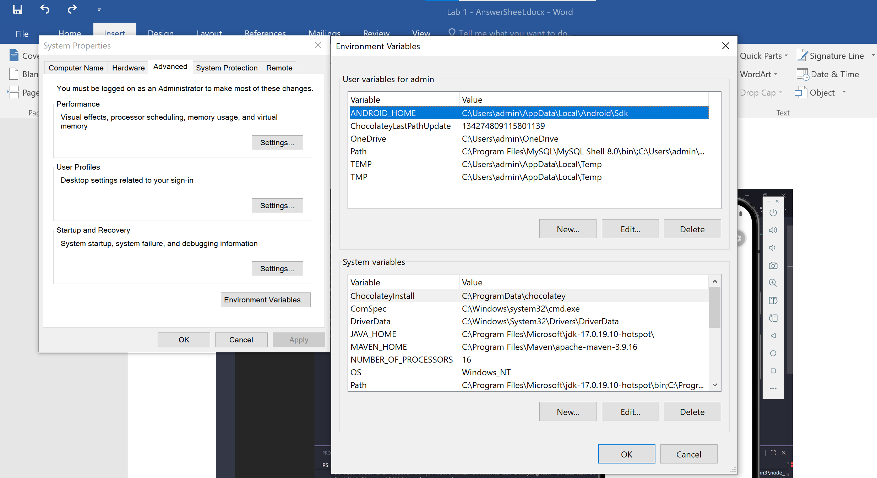

Question 3:
